**UCS 2312 Data Structures Lab**

**Assignment 10: Implementation of Shortest Path Finding algorithm**

The cityADT contains the number of cities and the connectivity information between the cities (adjacency matrix). Write the following methods. [CO2, K3]

* void create(cityADT *C) – will represent the graph using adjacency matrix
* void disp(cityADT *C) – Display the graph
* void Dijkstra(cityADT *C)
  + Displays the intermediate and final tables
* char * displayPath(cityADT *C, source, destination)
  + Find the path of the intermediate cities between the source and destination cities along with the cost

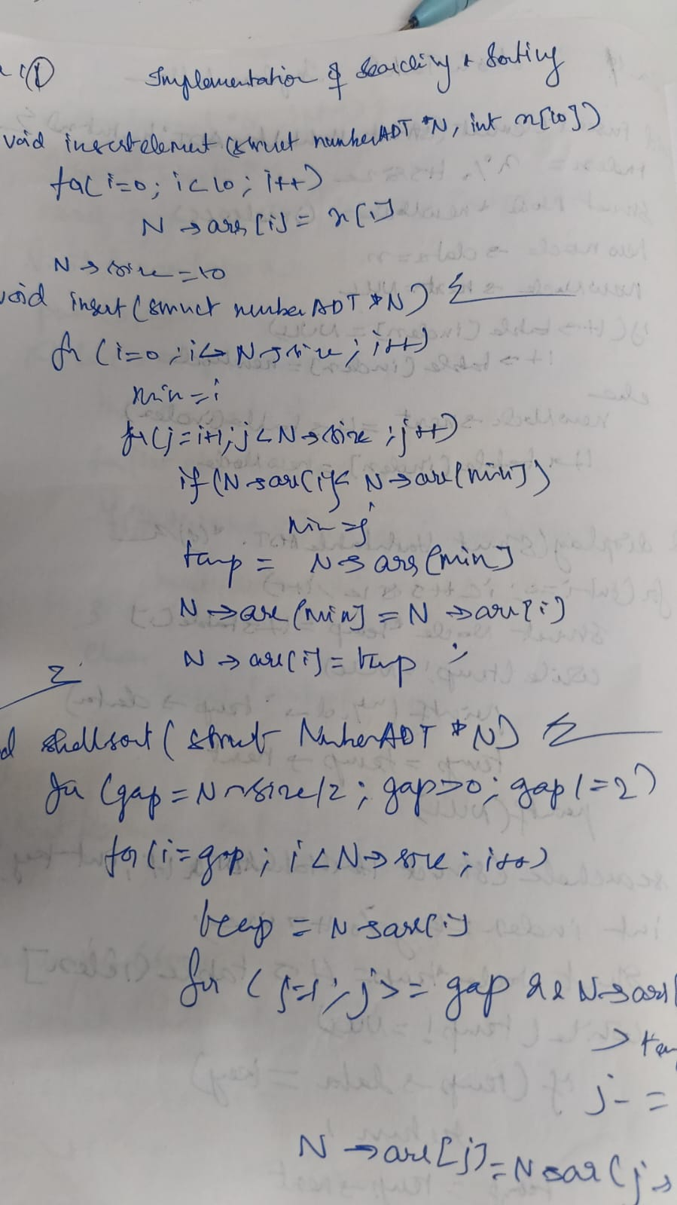

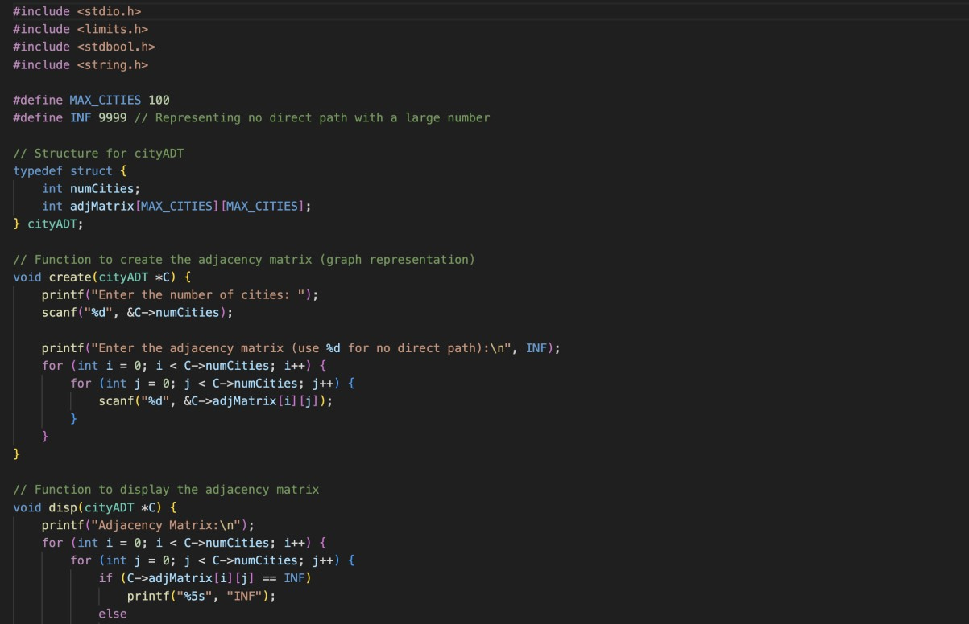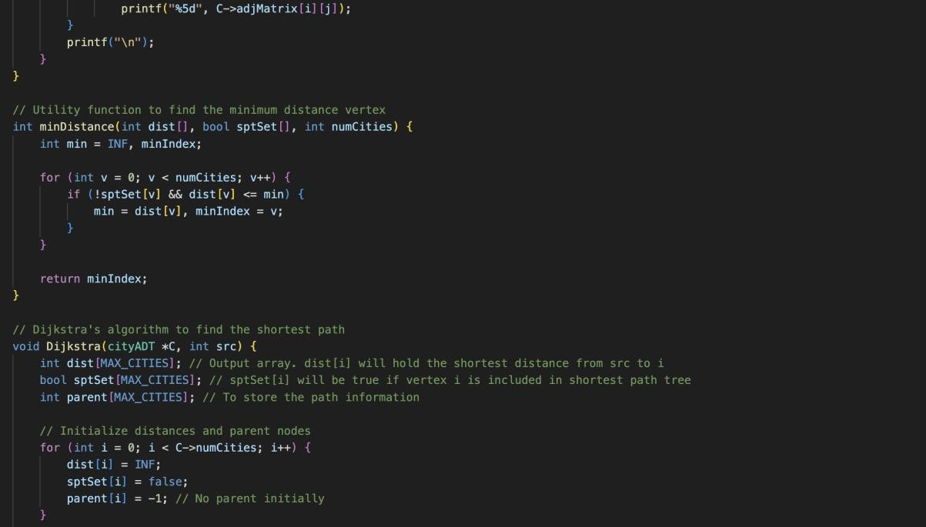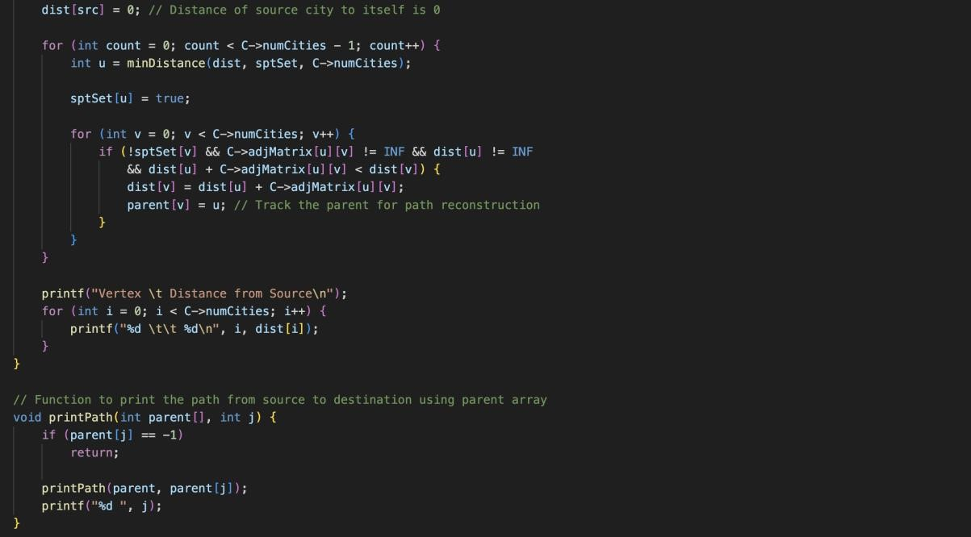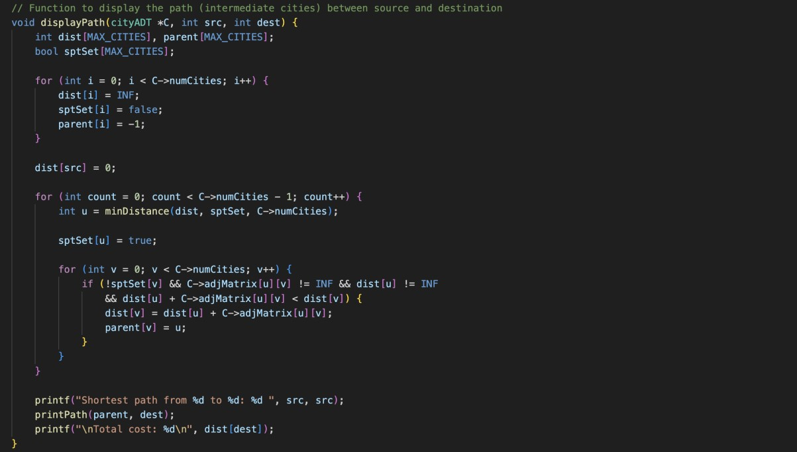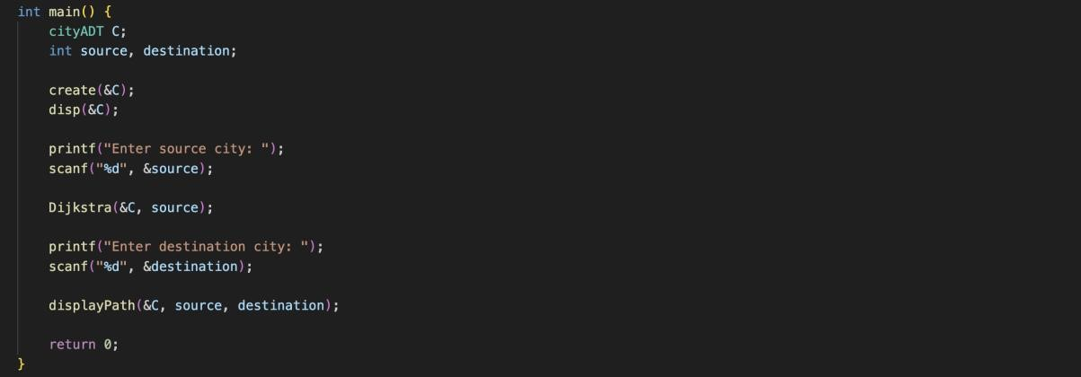

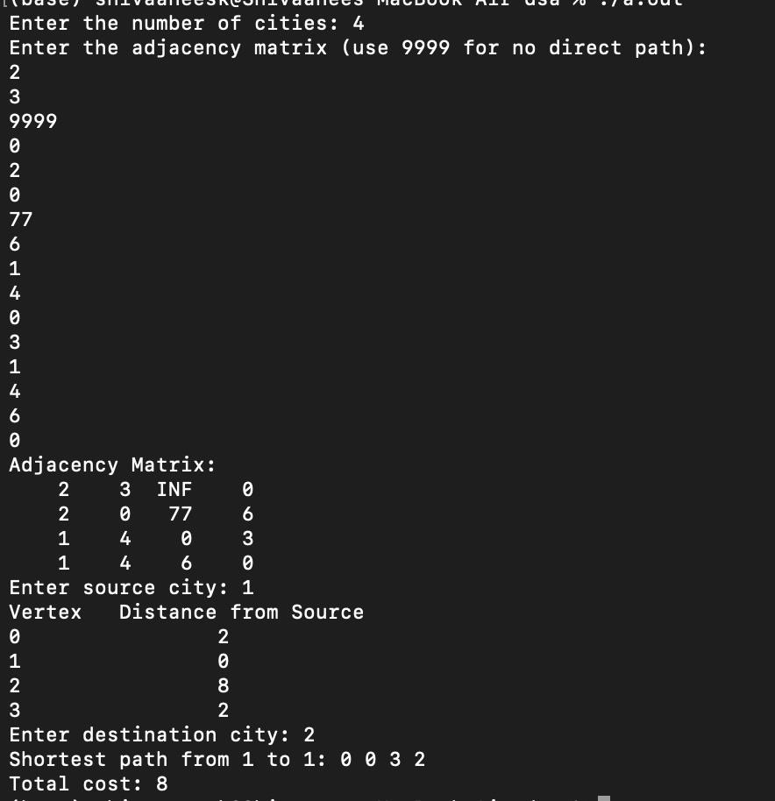

Technical Outcomes:

|  |  |  |
| --- | --- | --- |
| Design | 2 | Needs improvement |
| Understanding DS | 2 | Needs improvement |
| Usage of DS | 2 |  |
| Debugging | 3 |  |

Best Practices:

|  |  |  |
| --- | --- | --- |
| Design before coding | 2 |  |
| Usage of algo | 2 |  |
| Multifile | 3 |  |
| versioning | 3 |  |